Casey Gray
ITEC 4365
March 11, 2025
Assignment 5

Breaking down the steps and how they relate to the flowchart:

Step 1: In TDD, always start with a user story. This is a description of a feature that the user wants. In this case, the user wants an app that calculates the square footage of a room.
Step 2: Break the story down into smaller testable parts. Write a test case that focuses on a specific aspect of the story. This test should fail since no code has been written yet. For example, if I’m given a room with a width of 10 feet and a length of 12 feet, when the function for calculating the square footage is called, it should return 120 square feet, since 10 x 12 is 120. Here is an example of code that could be used:
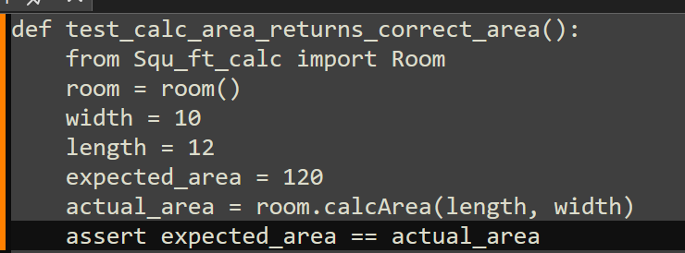
This will fail because no code has been written to actually calculate the area.
Step 3: Write just enough code to make the failing test pass. Here is where the code to calculate the area would be written. Once it returns the correct value, the test will pass.
Step 4: Run all tests, including the one just written.
Step 5: If all tests pass, refactor the code to make it more readable and efficient without changing its functionality. The tests make sure that nothing is broken during refactoring.
Step 6: Go back to step 2 and write a new failing test for the next part of the “user story.” Continue the cycle until the story (app) is complete.

The flowchart directly correlates to each step of the TDD process. Step 1: Story. Step 2: understand and add a single (failing) test. Step 3: Write code to make the test pass. Step 4: Run the tests. If the test fails, rework the code until it passes. Step 5: Make the code pretty. Step 6: If the story is not complete, go back to step 2 and add a new test.

